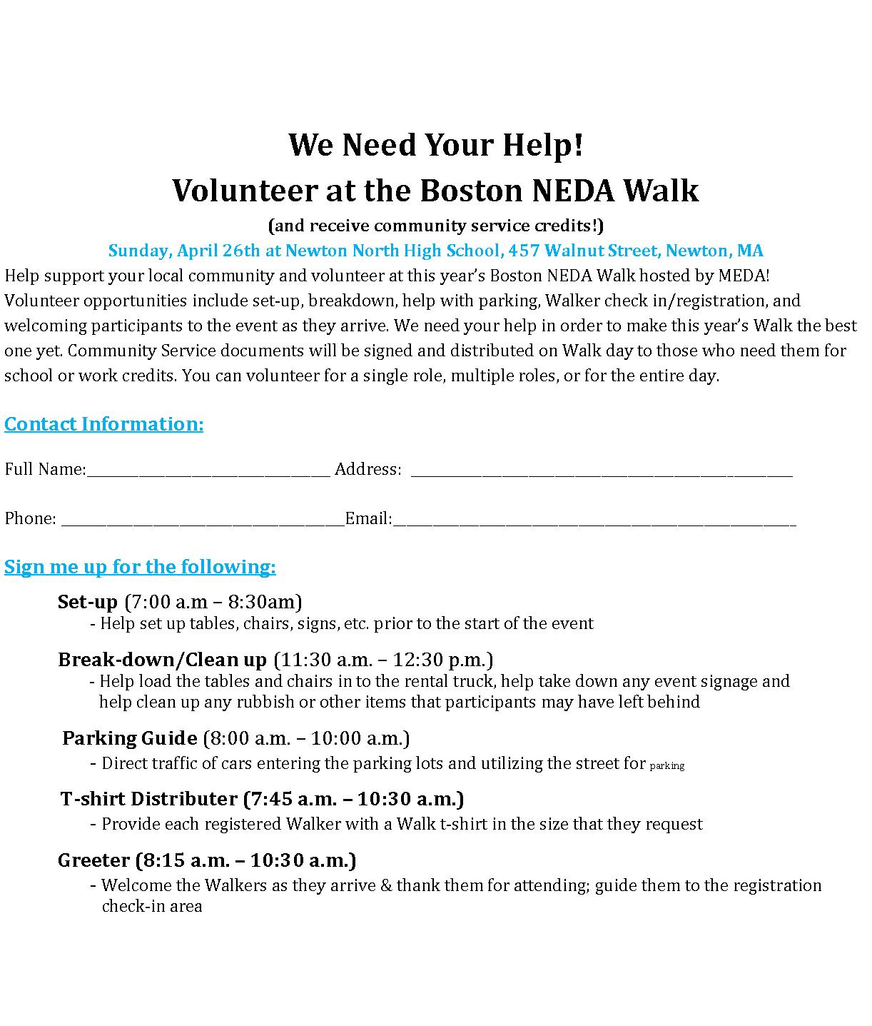

978

978

**Fill out the contact information above and put a check mark next to which opportunity you would   
like to volunteer for. You can volunteer for multiple opportunities. Once you have made your   
selection(s), please e-mail this completed form to** **Colleen Marfione at** [CMarfione@medainc.org](mailto:CMarfione@medainc.org).