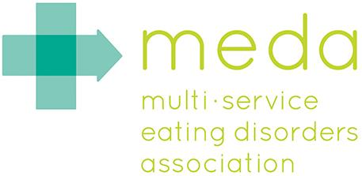 Kellys’ Story

When I think back on Nora’s journey I imagine how different it could have been if she didn’t ask for help. I am incredibly grateful that Nora was brave enough to acknowledge that she was scared and out of control. Even though she was only 13, she chose to enter treatment and she took her recovery very seriously from the minute she started.
I am grateful for my family - Nora’s brother and sister completely supported her throughout this journey. Every night that she was in treatment someone visited her. Sometimes it was my son and his girlfriend or my brother and sister in law or my mother. Nora had an incredible group of people who wanted to support her.
I also remember being grateful that Nora was never shy or embarrassed about her struggle. While others whispered about their eating disorder, Nora Tweeted. When others hid in the school bathroom crying, Nora sought support from her teachers and friends. She has created a network of people who are willing to drop everything if she just needs to talk about how upsetting something is. Nora came home from school one day and told me that her Art teacher had responded perfectly by saying, “Nora, I don’t understand how it feels, but I am here to listen any time you need me.”
I am grateful that Nora has become a resource – someone that other girls confide in. She doesn’t judge, she doesn’t gossip but she does listen and offer advice.

About 3 months after she had finished IOP, Nora told me that she was feeling alone and wanted to find other girls her age that had been in treatment. That is when we found MEDA – another thing I am grateful for. We drove here every Tuesday night so that Nora could participate in the Teen Group while I attended the Parent Group. We both learned so much – how to recognize behaviors that were re-surfacing and how to address them, how to acknowledge challenges and how and where to get help when we needed it. But most of all we met other families who were dealing with the same issues and we didn’t feel so alone.

I am grateful that Nora has found her voice and speaks up for herself. She is now a flourishing 15 year old and has been in recovery for two years. A turning point came before she started High School. We considered meeting with her guidance counselor to discuss Nora’s recovery and establish some expectations. It was then that Nora decided that she didn’t want to be defined as “the girl with the eating disorder”. She wanted to be recognized for her academic and athletic abilities. The bottom line was that she wanted to be a “normal teenager” so she decided to navigate the transition herself and she did it really well.

I won’t say that we don’t have our challenges and I don’t expect every day to be perfect, but I used to get calls from school every week because she was upset or overwhelmed. Those calls are almost non-existent because she has developed coping mechanisms to get her through stressful situations.

I am incredibly grateful that Nora never quits and never settles for anything less than the very best. She expects a lot of herself and of the people around her. She is funny and radiant. She is smart and beautiful. She is resilient and talented. My daughter is so much more than an eating disorder!

